**Class Test 02**

|  |  |  |
| --- | --- | --- |
| **Name** | **ID** | **STUDENT SIGN** |
| FARJANA YESMIN OPI | 22-47018-1 | Opi |

**PL/SQL**

**Part 01:**

1. Write a query that displays **Hello ADBMS Section A** usingtheconcept of literal.

**BEGIN**

**DBMS_OUTPUT.PUT_LINE('Hello ADBMS Section A');**

**END;**

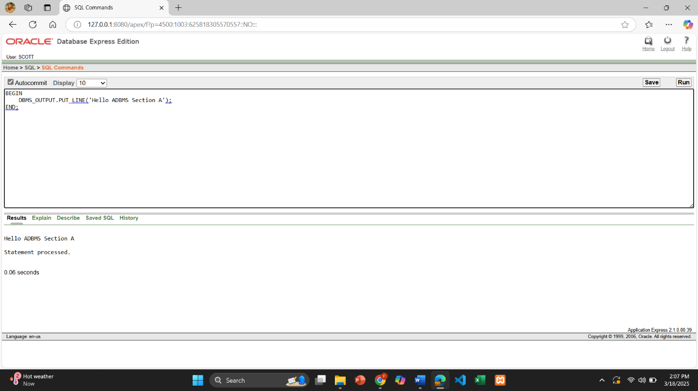

1. Write a query that can add two numbers using the concept of inner block and outer block.

DECLARE

num1 number := 10;

num2 number := 20;

BEGIN

DECLARE

temp_sum number;

BEGIN

temp_sum := num1 + num2;

DBMS_OUTPUT.PUT_LINE('Sum: ' || temp_sum);

END;

END;

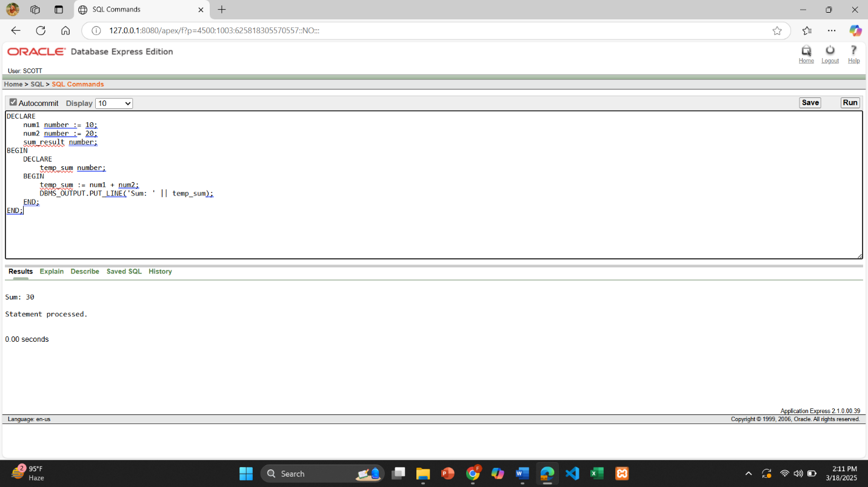

1. Write a query that can multiply three numbers using the concept of literal.

BEGIN

DBMS_OUTPUT.PUT_LINE('Product: ' || (5 * 6 * 7));

END;

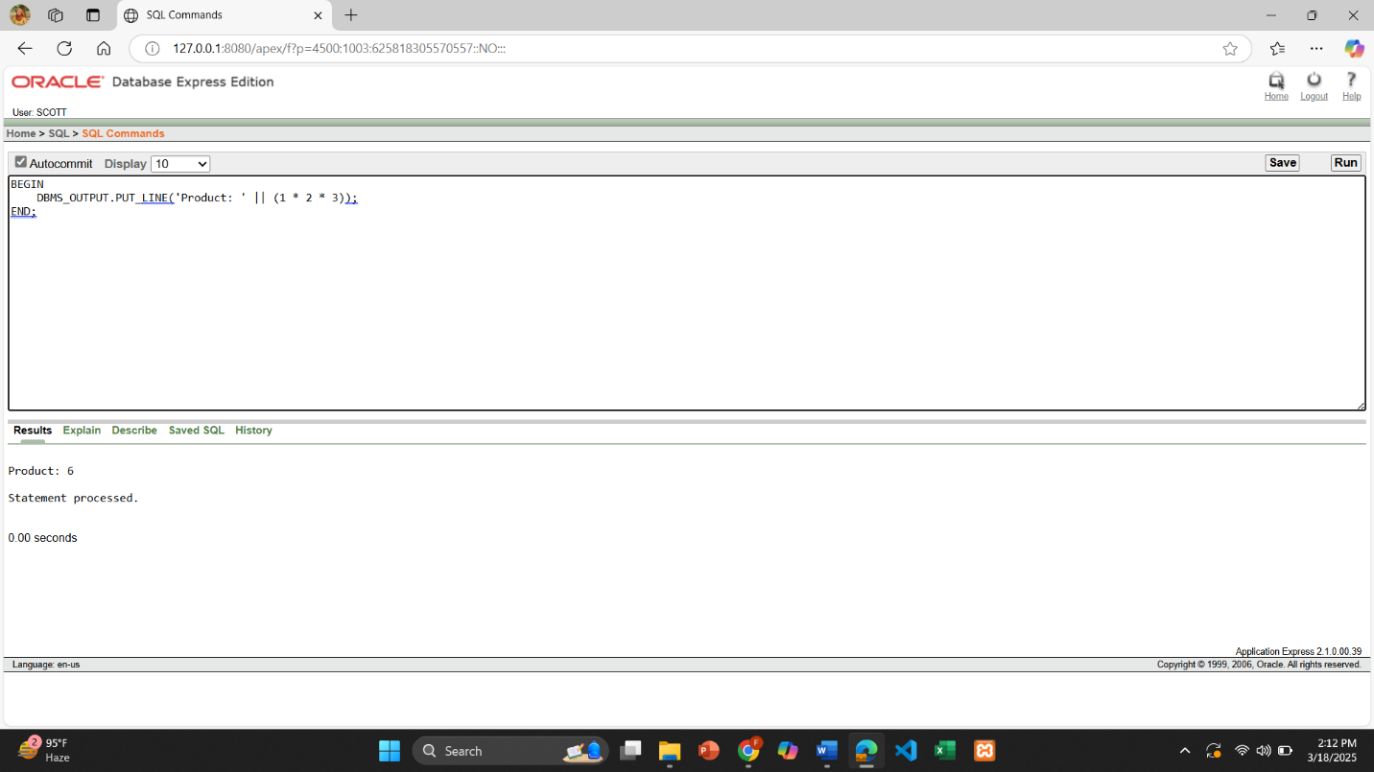

1. Write a query that stores **Hello World** in a variable and displays it in block letters.

DECLARE

msg VARCHAR2(20) := 'Hello World';

BEGIN

DBMS_OUTPUT.PUT_LINE(UPPER(msg));

END;

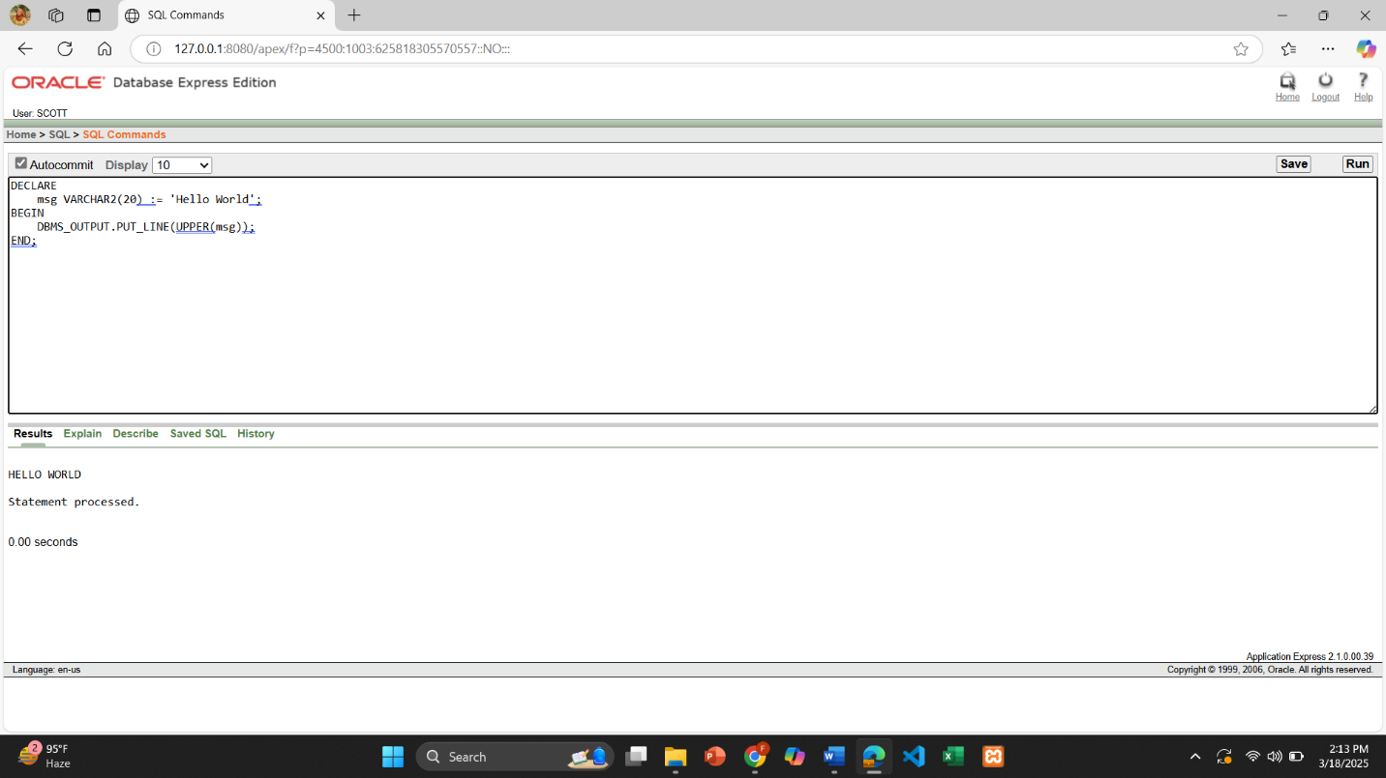

1. Write a query that can subtract a smaller number from a larger number and display the result using the concept of variable.

DECLARE

num1 NUMBER := 25;

num2 NUMBER := 10;

result NUMBER;

BEGIN

result := num1 - num2;

DBMS_OUTPUT.PUT_LINE('Result: ' || result);

END;

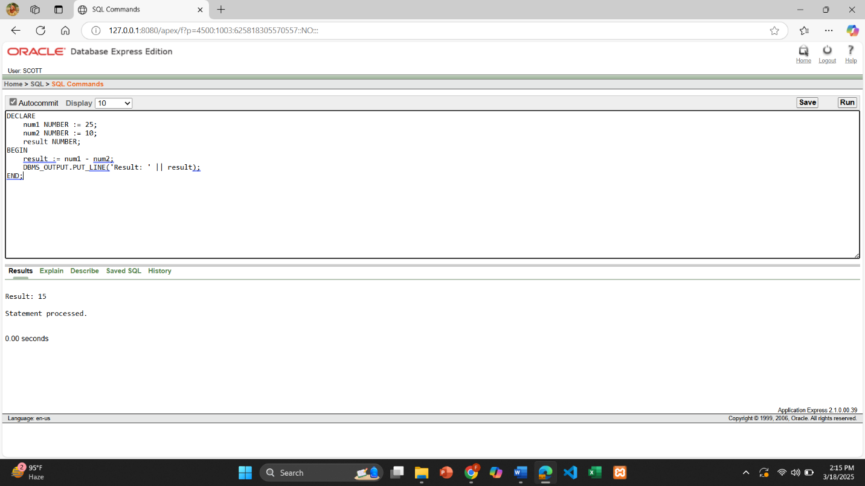

1. There are four numbers given i.e. 12,14,16,18. Find out the average.

DECLARE

num1 NUMBER := 12;

num2 NUMBER := 14;

num3 NUMBER := 16;

num4 NUMBER := 18;

average NUMBER;

BEGIN

average := (num1 + num2 + num3 + num4) / 4;

DBMS_OUTPUT.PUT_LINE('Average: ' || average);

END;

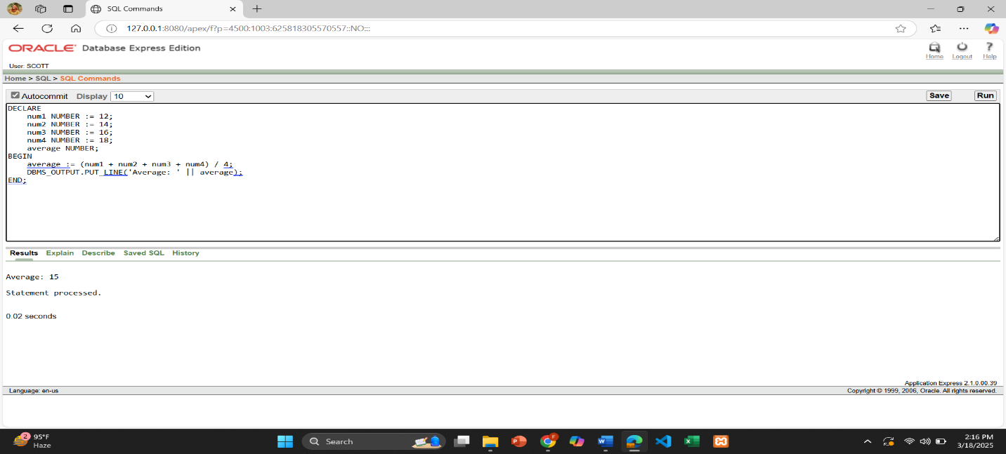

1. Write a query that displays the value of pi using the concept of constant.

DECLARE

PI_CONSTANT CONSTANT NUMBER := 3.1415926535;

BEGIN

DBMS_OUTPUT.PUT_LINE('Value of Pi: ' || PI_CONSTANT);

END;

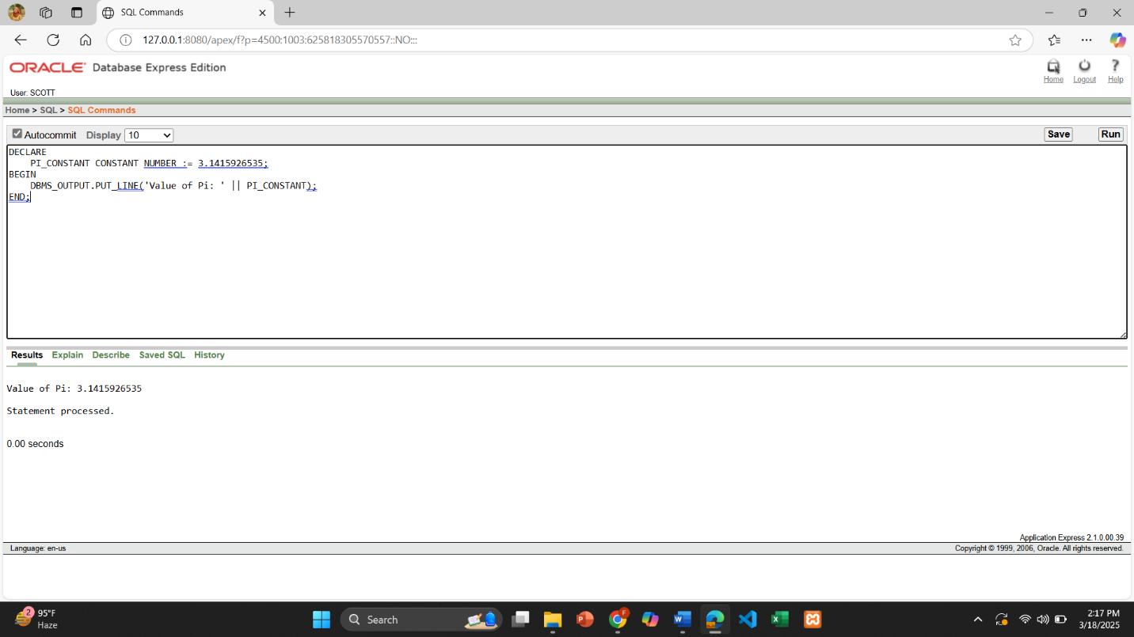

**Part 02:**

*To solve the following use the scott schema*

1. Write a query that can display the name of the department which has department number 10.

DECLARE

dname DEPT.DNAME%TYPE;

BEGIN

SELECT DNAME INTO dname FROM DEPT WHERE DEPTNO = 10;

DBMS_OUTPUT.PUT_LINE('Department Name: ' || dname);

END;

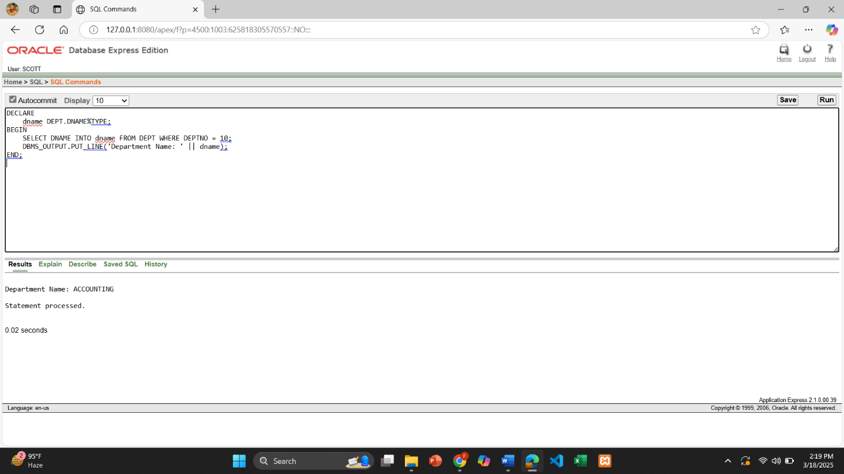

1. Write a query that can display the name of the department in lower case which has department number 20.

DECLARE

dname DEPT.DNAME%TYPE;

BEGIN

SELECT LOWER(DNAME) INTO dname FROM DEPT WHERE DEPTNO = 20;

DBMS_OUTPUT.PUT_LINE('Department Name in Lowercase: ' || dname);

END;

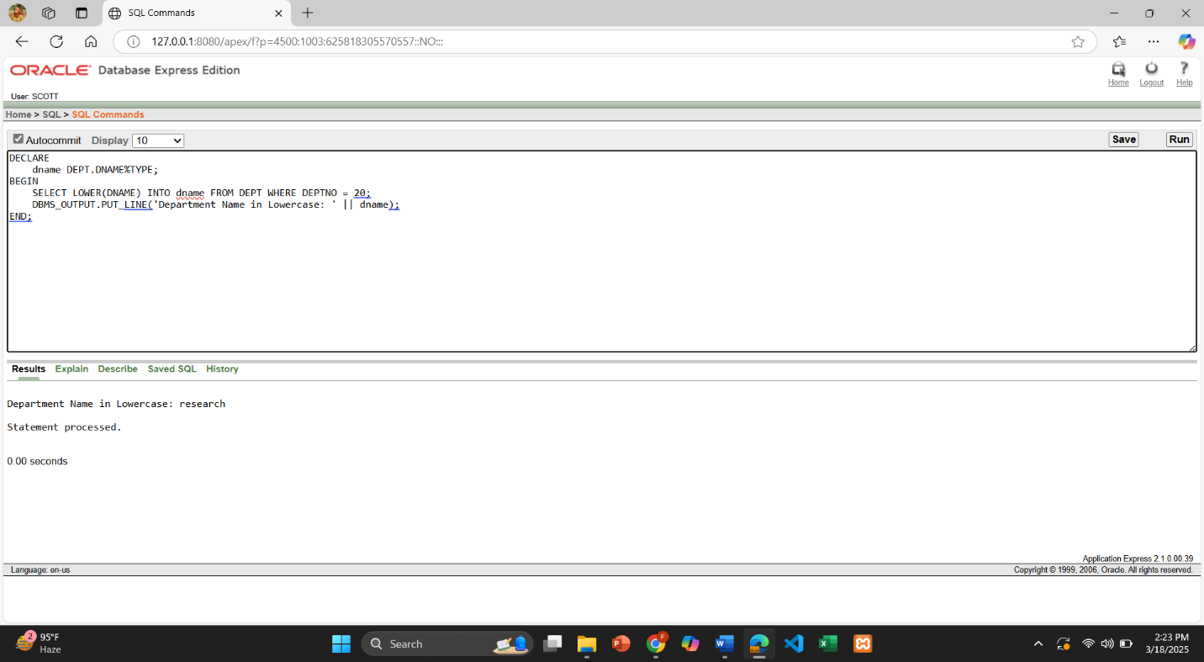

1. Write a query that displays the incremented salary (sal+250) of employee Smith.

DECLARE

salary EMP.SAL%TYPE;

BEGIN

SELECT SAL + 250 INTO salary FROM EMP WHERE ENAME = 'SMITH';

DBMS_OUTPUT.PUT_LINE('Incremented Salary of SMITH: ' || salary);

END;

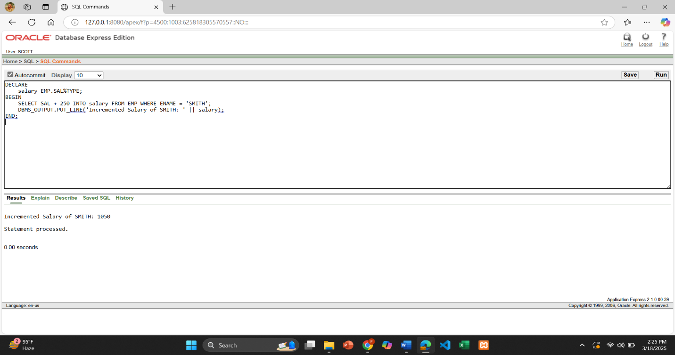

1. Write a query that displays the hiredate of employee KING.

DECLARE

hiredate EMP.HIREDATE%TYPE;

BEGIN

SELECT HIREDATE INTO hiredate FROM EMP WHERE ENAME = 'KING';

DBMS_OUTPUT.PUT_LINE(hiredate);

END;

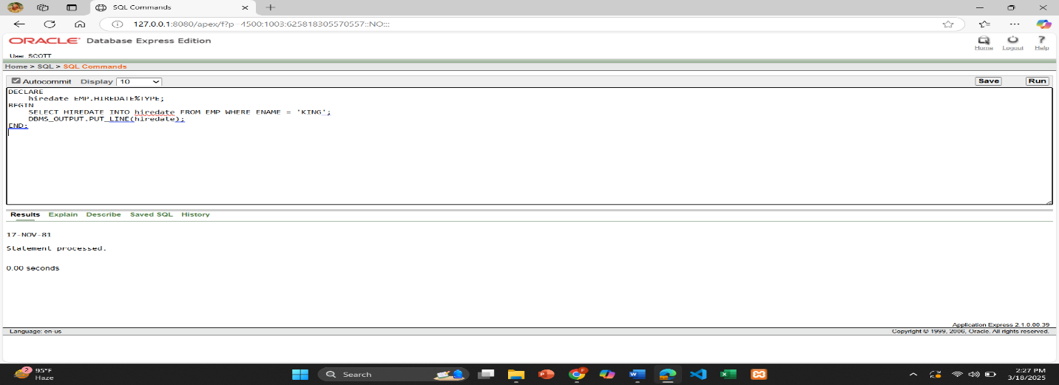

1. Write a query that displays the sum of salary of all the employees.

DECLARE

total_salary NUMBER;

BEGIN

SELECT SUM(SAL) INTO total_salary FROM EMP;

DBMS_OUTPUT.PUT_LINE('Total Salary of All Employees: ' || total_salary);

END;

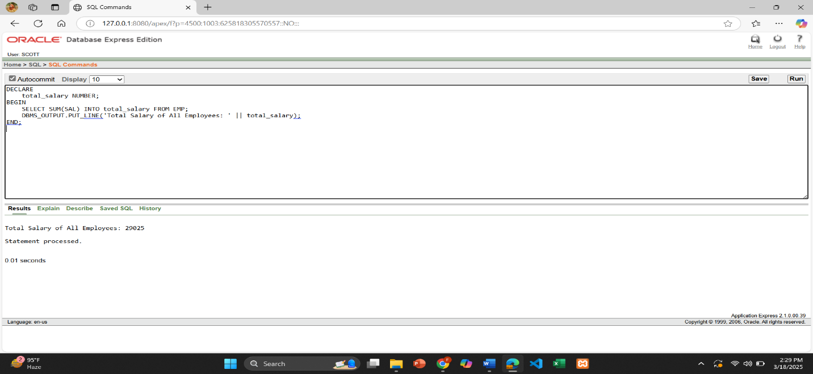

1. Write a query that displays the salary and commission of employee Allen.

DECLARE

salary EMP.SAL%TYPE;

comm EMP.COMM%TYPE;

BEGIN

SELECT SAL, COMM INTO salary, comm FROM EMP WHERE ENAME = 'ALLEN';

DBMS_OUTPUT.PUT_LINE('Salary of ALLEN: ' || salary);

DBMS_OUTPUT.PUT_LINE('Commission of ALLEN: ' || NVL(comm, 0));

END;

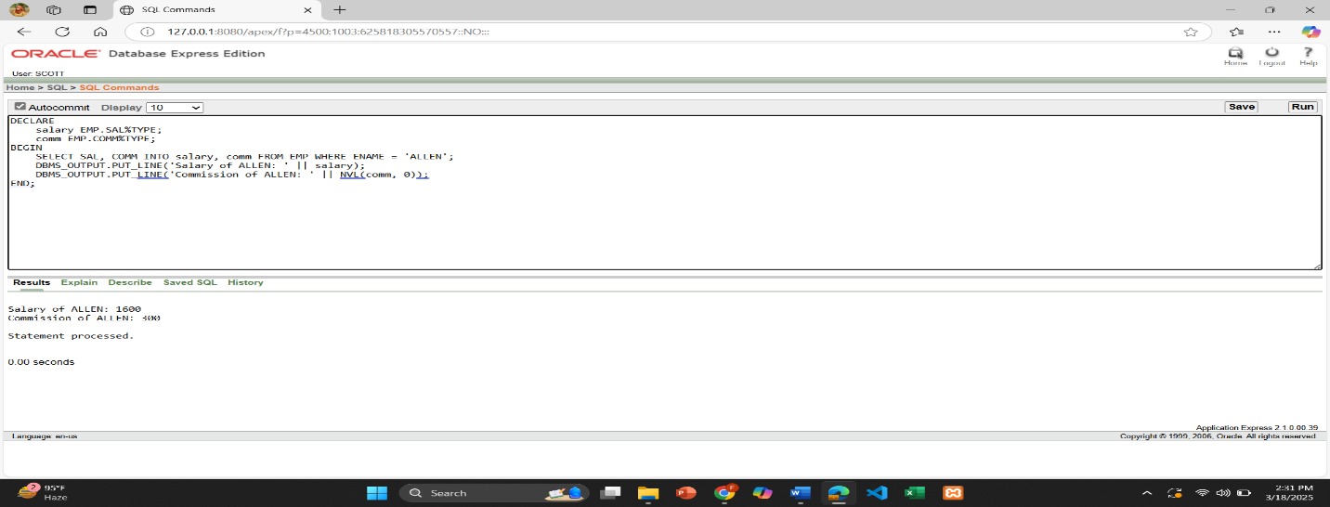

1. Write a query that displays only those employees who have *TT* (double T) in their name.

BEGIN

FOR emp_record IN

(SELECT ename

FROM emp

WHERE ename LIKE '%TT%')

LOOP

DBMS_OUTPUT.PUT_LINE('Employee Name: ' || emp_record.ename);

END LOOP;

END;

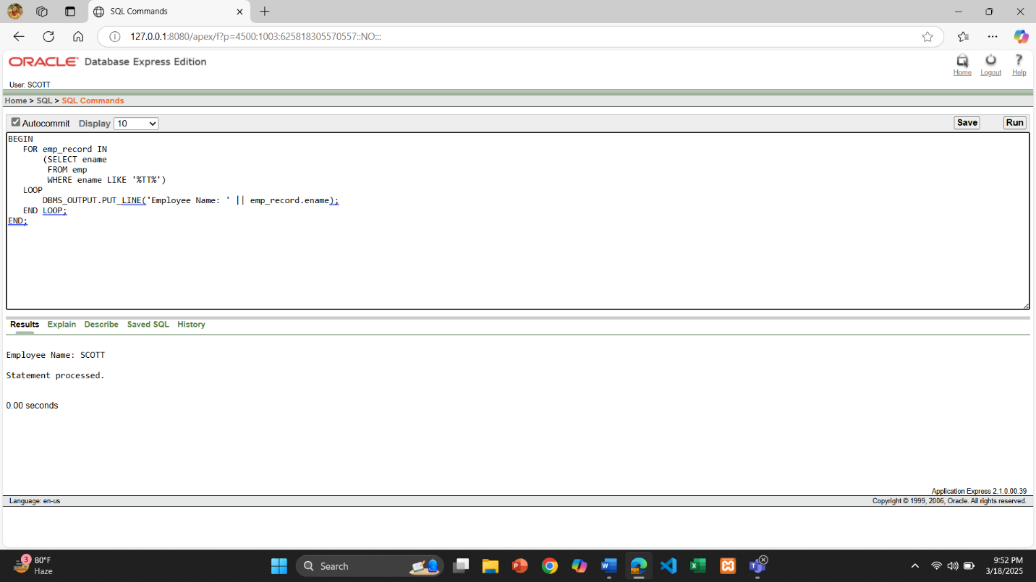

**\*\*After solving the above questions using Oracle 10g, write the PL/SQLs in a MS Word document (Write down the answer and give screenshot of the result of the query. The name of the document MUST be your ID and the PL/SQLs MUST be numbered accordingly) and upload it in the provided link in your VUES account**